5.1 Approximating Areas Worksheet

- Approximate the area under the curve of from by using…
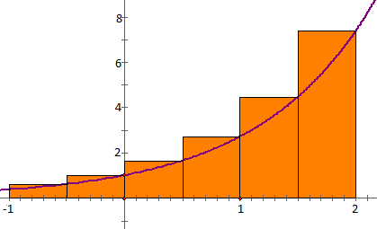
- a Right Riemann Sum with 6 rectangles.

This is an overestimate of the area.
(Note: not all Right Riemann Sums are overestimates)
Actual area:

- a Midpoint Riemann Sum with 3 rectangles.

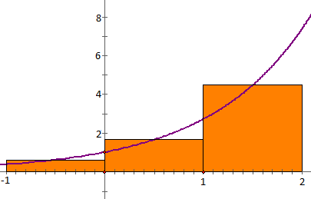

- Coal gas is produced as a gasworks. Pollutants in the gas are removed by scrubbers, which become less and less efficient as time goes on. The following measurements, made at the start of every other month, show the rate (in tons per month) at which pollutants are escaping in the gas over the course of one year.

Time $t$ (months) | 0 | 2 | 4 | 6 | 8 | 10 | 12
Rate pollutants escape (tons/month) | 2.5 | 8.0 | 12.5 | 15.0 | 16.5 | 17.5 | 18.0

Use a left Riemann sum with to approximate the total amount of pollutants that escape over the course of the year. Simplify your answer and include proper units.

We know that , so each rectangle has width 4.
The left endpoint of each rectangle occurs at .
So we obtain:
- Use a right endpoint Riemann sum to estimate the area between and the x-axis from -1 to 3 using 4 rectangles.

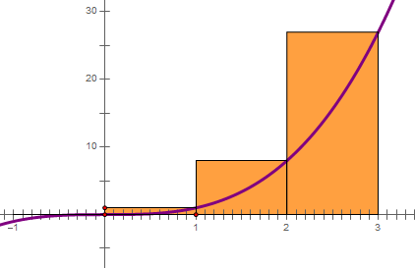

- A car is travelling at 60 feet per second when the driver sees a deer in the road 300ft ahead and immediately steps on the brakes. The deer freezes and does not move from his spot in the road. I’ve recorded the driver’s speeds (in ft/sec) every two seconds starting at the time that he first stepped on the brakes and going until the time that the car finally came to a stop. Does the car hit the deer? Use an appropriate Riemann sum the help answer this question.

Time | 0 | 2 | 4 | 6 | 8
Car’s speed | 60 | 46 | 28 | 12 | 0
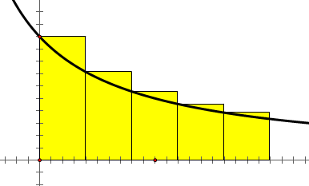
Example curve:

Since the cars speed is decreasing we know that a Left Riemann Sum approximation will be an overestimate of the distance the car travelled since it hit its breaks.

Left Riemann Sum:

Since 292ft is an overestimate we can be sure that the car does not hit the deer which is 300ft away!

- Approximate the area under the curve of from by using…

- Left Riemann Sum with 4 rectangles.
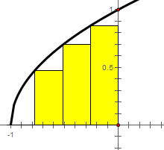

- Midpoint Riemann Sum with 2 rectangles.

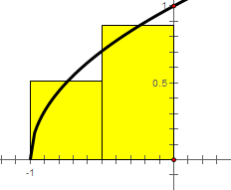

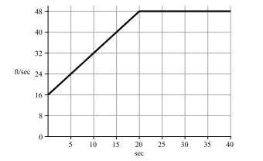
- An objects velocity in feet per second is given by the graph for the time interval shown. What is the exact total distance the object travels during the first 20 seconds of this interval?
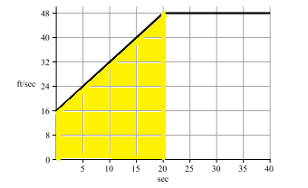

We can calculate that:
So, .

